QUESTION 1
- In an experiment, you take the following four measurements of an object's apparent shift (parallax) against a background grid:
Measurement 1: distance = 0.25 m, apparent shift = 27.7 cm
Measurement 2: distance = 0.50 m, apparent shift = 10.5 cm
Measurement 3: distance = 0.75 m, apparent shift = 3.8 cm
Measurement 4: distance = 1.00 m, apparent shift = 2.4 cm
Which of the following graphs represents your measurements?
1
2
3
4
10 points
QUESTION 2
- To measure the parallax of a nearby star, the star must be observed twice from Earth in a time interval of ___.
3 months
6 months
9 months
12 months
10 points
QUESTION 3
- Although the Moon never stops in its orbit around Earth, it is possible to get an exact measurement of its parallax and thus its distance at any given moment. What would we have to do to get the parallax shift of the Moon?
Take simultaneous measurements from two locations.
Take two measurements at different times from one location.
Take two measurements from the same location at the same phase of the Moon, separated by 1 month.
10 points
QUESTION 4
- Suppose astronomers put a telescope on Pluto, ~40 AU from the Sun, beaming back information to us. How much farther will they be able to measure accurate parallaxes compared to their work here on Earth?
20 times farther
30 times farther
40 times farther
just as far as from Earth
10 points
QUESTION 5
- Imagine that you measure the parallax of two stars in the constellation Leo. Regulus has one-half the parallax angle of Denebola. What do you immediately know about the relative distances of these stars from Earth?
Both stars are at the same distance from Earth.
Regulus is twice as far away from us as Denebola.
Denebola is twice as far away from us as Regulus.
The relative distances cannot be determined with the information given.
10 points
QUESTION 6
- Rank the stars in Table 18.2 in order of distance from Earth (closest = 1, farthest = 4).
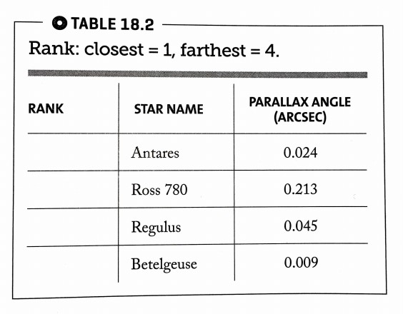
Antares  Ross 780  Regulus  Betelgeuse | A. 1  B. 2  C. 3  D. 4
10 points
QUESTION 7
- Match the stars in Table 18.3 with their corresponding distances.
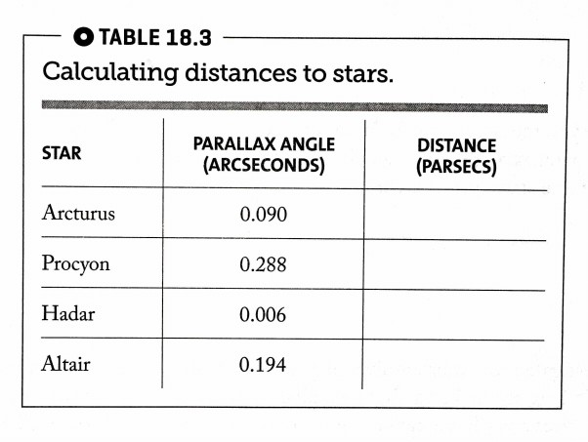
Arcturus  Procyon  Hadar  Altair | A. 3.47 pc  B. 5.15 pc  C. 11 pc  D. 167 pc
10 points
QUESTION 8
- Table 18.A lists the three stars of Orion's belt. Which of the following ranks these stars from nearest to farthest?
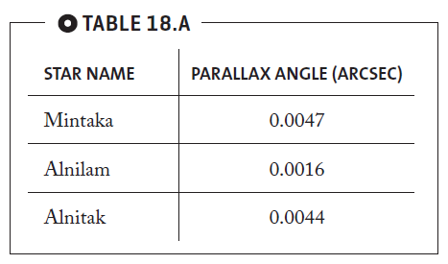
Mintaka, Alnilam, Alnitak
Alnilam, Alnitak, Mintaka
Mintaka, Alnitak, Alnilam
10 points
QUESTION 9
- Alnilam is approximately how many times farther away from us than Mintaka?
3
7
10
100
10 points
QUESTION 10
- The parallax for the star Sirius in the constellation of Canis Major is 0.379 arc seconds; the parallax for the star Rigel in the constellation of Orion is 0.00378 arc seconds. Approximately how much farther away from us is Rigel than Sirius?
10 times farther
100 times farther
1000 times farther

